**CHAPTER 3: METHODOLOGY AND MATERIALS USED**

* 1. **INTRODUCTION**

The word "methodology" refers to a process for determining the best solutions to a problem. We use this process to accomplish our primary or targeted goals.

When thinking about how to create a system that keeps track of student attendance and allows them to give feedback without revealing their identities, it's important to look at the methods and tools used. By exploring different ways and technologies, we hope to design a system that is easy to use and efficient for both students and teachers. This section will outline the steps taken to develop and implement the student attendance and anonymous feedback system. Various tools will be explored, techniques, and software to create a system that meets the needs of everyone involved. This methodology will help in understanding how to collect attendance information, keep feedback anonymous, and use technology to enhance the educational experience. By carefully examining the tools and strategies available, the goal is to create a system that works smoothly and benefits the entire educational community.

* 1. **Description of the architecture of the system or application**

The conception of a good application entails the designer to select the best technology, the appropriate tools, the adapted software necessary and not forgetting to respect the methodology to be used in order to realize the platform and satisfy users with their needs. The architecture of a web application here is talking about an approach to the design and planning of websites that involves technical, aesthetic and functional criteria. As in traditional architecture, the focus is on the user and on user requirements. It also entails employing software, human resources, techniques and information flow in the system.

In a typically 3-tiered architecture, users point their browsers to the application server to start using the application. However, the setup of that environment can be considerably more complex than setting up a database for the users to connect to, and making the installer for the client available. 3-tier for users is the most advantageous of these tiers and this is why it has been chosen as our architecture of preference and because 3-tier has the potential of greater speed and security than the 2-tier architecture. Due to the importance of this web applications and the organization in which the information shall flow within the information system, we have chosen the 3-tier architecture which involves the following points:

* Data are shared on a focal point
* The layout of the application is taken in charge by the computer-client
* Application server also named middleware is the one in charge of providing the resources by calling another server named database server.

The figure below represents a 3-tier architecture where we have the client, database and the application servers which is the choice for our dissertation:

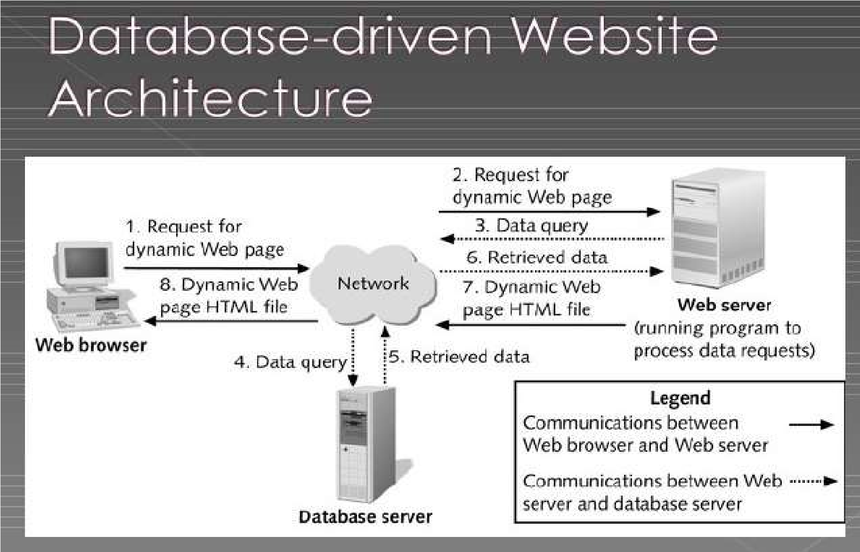

Figure 1: Architecture of the system (http://www.slideshare.net, 2016)

**3.3 Data collection method and user’s need**

A good web application should take into account the assembly of data collection and user’s needs. It is not possible to realize a web application without studying the information system. So, a good web application should answer the user’s needs with the help of the various methods of data collection put in place. However, the choice of a particular data collection method to be used depends on the objectives the researcher wants to attain at the end. As part of our research, we have chosen to gather information and ascertain users' demands through interview and observation.

**3.3.1 Observation**

In observing the implementation of a system that combines student attendance tracking with an anonymous feedback platform, it becomes evident that the integration of technology plays a crucial role in streamlining educational processes. The system facilitates the seamless monitoring of student presence in classes while providing a channel for students to share their perspectives without the fear of identification. Through this observation, it is clear that leveraging modern tools and methodologies can enhance communication between students and educators, leading to a more inclusive and responsive learning environment. The observation highlights the potential of such a system to foster transparency, improve student engagement, and tailor teaching approaches to better meet the needs of learners. As the system continues to be utilized, on-going observations will be essential in evaluating its impact on student participation, feedback quality, and overall educational outcomes.

**3.3.2 1nterviews**

During the development and evaluation of a system that integrates student attendance tracking and anonymous feedback mechanisms, interviews play a vital role in gaining valuable insights from stakeholders. These interviews involve interacting with students, faculty, and administrators to understand their perspectives, requirements, and expectations regarding the system. The interviews aim to gather feedback on the usability, effectiveness, and overall usability of the system. The findings from these interviews can help identify potential issues, improve system functionality, and ensure that it meets end-user requirements and preferences. Interviews also provide an opportunity to include valuable suggestions and feedback from stakeholders, ultimately contributing to the successful implementation and improvement of the student attendance and anonymous feedback system.

**3.3.3 Experiments**

Several experiments can be conducted to test and validate the effectiveness of a system that combines student attendance tracking and an anonymous feedback platform. These experiments are designed to evaluate various aspects of the system, including its functionality, usability, student engagement, and its impact on feedback quality. Some potential experiments include:

1. Usability Testing: Conduct usability testing sessions with students and teachers to evaluate the ease of use and navigation of the system. Participants can perform specific tasks on the system and provide feedback on their experiences.

2. Feedback Quality Assessment: Analyze feedback collected through the system to assess the quality, relevance, and constructiveness of anonymous comments. This allows us to understand the value of the feedback received and identify areas for improvement.

3. System Performance Assessment: Test system performance under a variety of user loads and scenarios to ensure system stability, responsiveness, and scalability. The purpose of this experiment is to identify potential bottlenecks or issues in the system.

4. Impact on Student Engagement: Conduct surveys or observational studies to assess the impact of the system on student engagement, attendance, and overall interaction with course materials.

5. Satisfaction Survey: Collect feedback from students, faculty, and administrators through surveys to assess their satisfaction with the system and solicit suggestions for further improvements

**3.3.4 User’s needs**

A relevant web application should be designed according to the users’ needs, because a good developer or a programmer must not realize a web application without taking in to account the users’ needs. The students need to be assured that their feedback will indeed be anonymous and their attendance is well analysed and taken down by teachers.

**3.4 Functional requirements**

In this light, we are looking at the various basic computer components needed to permit our application function well and serve its intended audience. Some of these components (requirements) are; a good RAM, processor, hard disk and peripheral input and output devices (monitor, mouse and keyboard).

**3.5 Function specifications**

The functional specification includes actors which will interact to actually bring out the role of this application at ESCHOSYS TECHNOLOGY and at the society and how this application will play this role with the help of its actors which we are to discuss below:

**3.5.1 Role played by each actor in the system**

Administrator

* Adds teachers
* Adds students
* Views attendance
* Marks attendance
* Views feedback
* Removes teacher
* Removes student

Teacher

* Marks attendance
* Sends documents
* Views feedback
* Adds student
* Removes student

Student

* Adds feedback on teacher
* Uploads documents
* Likes feed
* Dislike feed

**3.5.2 Functionalities of the system**

The most important functionalities of the system involve:

1. Automatic attendance tracking: This feature allows students to mark their attendance electronically, saving time and providing accurate attendance records for teachers to monitor.
2. Anonymous Feedback Platform: Providing students with the ability to provide anonymous feedback is critical to providing honest, constructive feedback that can help improve teaching methods and course content.
3. Data Analysis and Reporting: The ability to analyse attendance trends and feedback data, present it visually, and gain insights from the data is essential to making informed decisions and improving the overall educational experience.
   1. **Technical specifications**
4. A login page for the actors in the system should be included on the main page.
5. The platform should display an interface here the administrators can login into the system.
6. Both the admin and the teacher have a similar home page but with a difference in the level of their various menus
   1. **Non-technical specification**

* **At the level of security:** Like any web application that we have the chance to visit the administrators won’t be able to log in to any other administrators account without prior authorization from the administrator. Here, each administrator account is confidential to him or her.
* **Performance level:** The internet connection should be very fast with ahigh bandwidth.
* **Scalability:** The system should be scalable to accommodate the needs of growing businesses. It should be able to handle increasing transaction volumes without compromising performance or functionality.

**3.8 Research design**

The research seeks to explore how the implementation of an integrative student attendance and anonymous feedback system affects the communication processes and involvement of students within the academic processes.

Participants will include university students and teachers from different departments in the institution.

Methodology:

* Design: The research will employ quasi experimental design in which there will be a comparison of outcomes with a control experimental group applying conventional ways of recording attendance and giving feedback as opposed to the experimental that will use the integrated system.
* Data Collection: Quantitative data concerning how many students attended classes, how many students provided feedback, how many times students interacted with the system’s components will be recorded and statistics generated. Moreover, other qualitative data will be obtained through the use of surveys or focus groups to obtain user’s views and experiences.

**Some of the importance of this to the various stakeholders includes:**

For Teachers

**– Enhanced Understanding:** The system has provisions that allow an easy way for teachers to monitor attendance and the reporting of students’ absences and late arrivals or the prevalence of such trends which would aid in taking action in good time.

For Students

**– Providing Feedback**: Helps learners address their issues, including class related concerns, or suggestions about the course to remain anonymous as to allow maximum critique.

For Administrators

**– Management by Objectives**: Provides access to current information on attendance in particular lectures and opinions about them, which is important for improving the academic process and helping the students.

# 3.9 ANALYSIS METHODS

The scientific approach method is that which the researcher is guided to make appropriate software and that method entails an analysis which makes the design of a web application such as this to be put in place. This involves first of all the collection of information on the field passing through the need and flow of information within a particular information system in order to design software closely to the users’ needs. We will step by step look through or present the different types of methods under the large set: The object-oriented methods and the functional methods. At the end we will precise the best method suitable in the realization of our web application by giving the raisons d’être of our choice.

# 3.10 OBJECT- ORIENTED MODELING

The Object-oriented methods (OOMs) describe the static structure of the objects, their classes and their relations. One can mention here the following OOMs: OMT method, UML method and UP.

## 3.10.1 Object Modelling Technique (OMT) Method

The Object Modelling Technique (OMT) is an object modelling method for software modelling and designing. It was developed around 1991 by Rumbaugh, Blaha, Premerlani, Eddy and Lorensen as a method to develop object-oriented systems and to support object-oriented programming (ESPINASSE, 1980). OMT was developed as an approach to software development. The purposes of this modelling according to Rumbaugh are:

* Testing physical entities before building them (simulation).
* Communication with customers.
* Conception (alternative presentation of information).
* Reduction of complexity.

**OMT has proposed three main types of models:**

* **Object model:** The object model represents the static and most stable phenomena in the model domain. Main concepts are classes and associations with attributes and operations.
* **Dynamic model:** The dynamic model represents a state or transition view on the model.

Main concepts are states, transition between states and event to trigger transitions. Actions can be modelled as occurring within states. Generalization and aggregation (concurrency) are predefined relationships.

* **Functional model:** The functional model handles the process perspective of the model, corresponding roughly to data flow diagrams. Main concepts are process, data, data flow and actors.

## 3.10.2 Unified Modelling Language (UML) Method

UML is a language of modelling unified object in an object-oriented environment developed in response to the call for the proposal launched by the Object Management Group (OMG) with the goal of defining the standard notation for the modelling of applications built using objects. The principal authors of UML are Grady Booch, Ivvar Jacobson and Jim Rumbaugh.

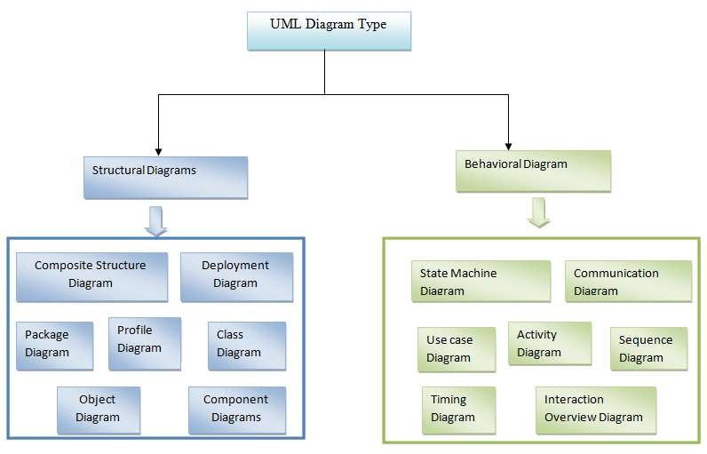

### Figure 2: Overview of UML (static3.creately.com, 2016)

Some advantages of UML are:

* Formal and standardized language, it allows proceeds of precision and constitutes a pledge of stability. This is what encourages the use of the tools.
* Powerful support of communication.
* Implementation of all the richness of the object approach.
* Description of all the models from the analysis to the realization of the software.
* Standardization of the concept’s objects.

Some limits of UML are:

* The semantics of UML is not formalized. It is specified by using the natural language.
* Difficult optimization of the choice of the classes.

Various categories of diagrams are not formalized.

## 3.10.3 Unified Process (UP) Method

Unified Process (UP) is a management method in the life cycle of software development and thus for object-oriented software. This as a generic method, iterative and incremental unlike the sequential method MERISE or SADT. This method is the general precept methods with the abbreviations: RUP, UPA, XUP, EUP, 2TUP, AM, DCU. Thus, an embodiment according to UP, to transform the software needs of users, must necessarily have the following characteristics:

* UP is based on components
* UP uses UML
* UP is driven by use cases
* UP centric architecture
* UP is iterative and incremental.

Some advantages of UP are:

* Use case sensitive
* Architecture centric
* Iterative and incremental.

Some limits of UP are:

* It is used only at the beginning of the whole process to create business requirements.
* The final application reflects the business processes, but there exist no closer bond between them.
* A small change in the business process leads to a fundamental change of the created information system.

# 3.11 FUNCTIONAL METHODS

The functional methods have their origin in the development of the procedural languages. More directed towards the managements than towards the data, they highlight the functions to be ensured and propose a hierarchical, downward and modular approach by specifying the bonds between the various modules. With the evolution of systems and programming languages, these methods took into account the modelling of the data and the problems arising from real time.

## 3.11.1 SADT Method

Structured Analysis and Design Technique (SADT) Method is a method of American origin developed in 1977 by DOUG ROSS then introduced in Europe since 1982 by Michel GALINER. It is a multi-field language which supports the communication between users and originators. As a method of functional analysis and the most known management of projects, SADT presents strong points and weak points.

Some advantages of SADT Method are:

* Its simplicity
* Its adequacy to capture the user's needs
* Its capacity with being able to produce solutions on several levels of abstraction.

Some limits of SADT Method: are:

* Its analysis is concentrated much on the functions, the coherence of the data being neglected.
* The rules of decomposition are not explicit. The decomposition differs according to analysts.
* Its difficulties of taking account of the non-hierarchical interactions in the complex systems.
* Lastly, the volatility of the functions makes that the system is in perpetual D-design.

## 3.11.2 MERISE Method

The MERISE (Methode d’Etude et de Realisation Informatique pour les Systems d’Entreprise) method was launched around 1977 through a national consultation launched by the French Ministry of industry with the aim to create a company of data processing consultant in order to define a method of design of information system. The Merise method is based on separation of data and treatments to be carried out in several conceptual and physical models.

The Merise method recommends three levels of abstraction; the conceptual level, the organizational level and the physical level.

**The conceptual level:** The conceptual level defines the finalities of the company. It is on this level that objectives to reach and constraints which weigh on the company are identified. It generally constitutes the most stable level and the first level of development. At the conceptual level, one distinguishes the Conceptual Data Model (CDM) and the Conceptual Treatments Model (CTM).

**The organizational or logical level:** The organizational level describes the organization which it is desirable to be set up in the company to achieve the laid down objectives. The purpose of it is to provide a diagrammatic representation of the organization of the company. One has heard of the Logical Data Model (LDM) and the Organizational Treatments Model (OTM). The organizational level is less stable and constitutes the second level of invariance.

**The physical level:** The physical level describes the means which will be implemented to manage the data and to activate the treatments. It is organized around the Physical Data Model (PDM) and the Operational Treatments Model (OTM)Table 1 below represents the three levels:

|  |  |  |
| --- | --- | --- |
| Levels | Static (Data) | Dynamic (Treatments) |
| Conceptual | CDM | CTM |
| Physical | PDM | OpTM |
| Logical and Organizational | DLM | OTM |

Table1: Representation of the levels of perception of Merise

Some advantages of MERISE Method are:

* Merise is considered like a method of design of information systems on the plan of its general organization. For this reason, it has many advantages:
* Merise allows the comprehension and the formalization of the needs for the trade
* Merise supports the dialogue between originator and owner, building particularly in the projects of integrated system development of management.
* Merise allows the general modelling of the data for construction of a database.
* Merise ensures the formalization of the user's needs within the framework of a schedule of conditions, before the work of design.

Some limitations of Merise Method are:

In spite of its many advantages, the Merise method was often criticized as being a Franco-French historical method. Its disadvantages can be analysed around three points:

* Merise is more turned towards the engineering of general design than towards the software genius
* Difficulty in maintaining the system.
* Not easily evolutionary system.

# 3.12 CHOICE OF METHOD

Research on this work has presented: OMT, UML, UP, SADT and MERISE as some of the principal models that can be used in designing an application. As a methodology to be used in this work, UML has been chosen to design our application. Automatically, UML will use the UP method because UP uses UML notations. The reason why UML is chosen is because in UML, the dynamic (behavioural) and static (structural) things are fused into the system’s entity to realize good and desirable results. This creates interdependency between the static and the dynamic things. It also provides precision and stability of the system. Hence, it is faster in building our application using the UML to MERISE method. The MERISE method on the other hand, separates static approach system from the dynamic approach. It uses data models in representing the static system and treatment models in representing the dynamic system, it is not a method made specifically for software development like UML but rather, it (MERISE) is generally used thus making the building of the application slower and costlier because more materials are used to attain the same but less reliable result in quality and quantity.

# 3.13 APPLICATION OF METHOD

As it is often said, a picture is worth a thousand words, this absolutely fits while discussing about UML. UML is a pictorial standard and modelling mechanism for specifying, visualizing, constructing, and documenting the artifacts of software systems. So beyond reasonable doubts, UML will help us better realize our application and understand its functionality.

## 3.13.1 Actors

An actor specifies a role played by a user or any other system that interact with the system but which is external to the subject. In our case we have the following actors:

**Administrator:** The administrator is in charge of the administration of the system and also carrying out daily attendance record. Therefore, an administrator acts as an individual handling or doing the general overseeing of the system. The roles are identified as follows:

* Create, edit and delete users (teachers and students).
* Check the list of all students and teachers.
* Can create new admins in the system.
* Can give a particular access level to the admin.

**Teacher:** The Teacher is in charge of the checking and navigating through the system and also carrying out daily attendance. The roles are identified as follows:

* Create, edit and delete students.
* Add documents to the system on the student site.
* Check the list of all students.
* Can create new students.

**Student:** The Student is in charge of sending feedback on teacher and either liking or disliking an already available feed (agreeing or disagreeing): The roles are identified as follows:

* Send feedback on teacher
* Has access to documents
* Like or dislike a feed.

## 3.13.2 Diagrams

1. **The Use Case Diagram**

The use case diagram is one which clearly shows all the actors in a given system and how those said actors interact with that system. This part contains the analysis of the functional and non-functional requirements using use case diagram and use case details.

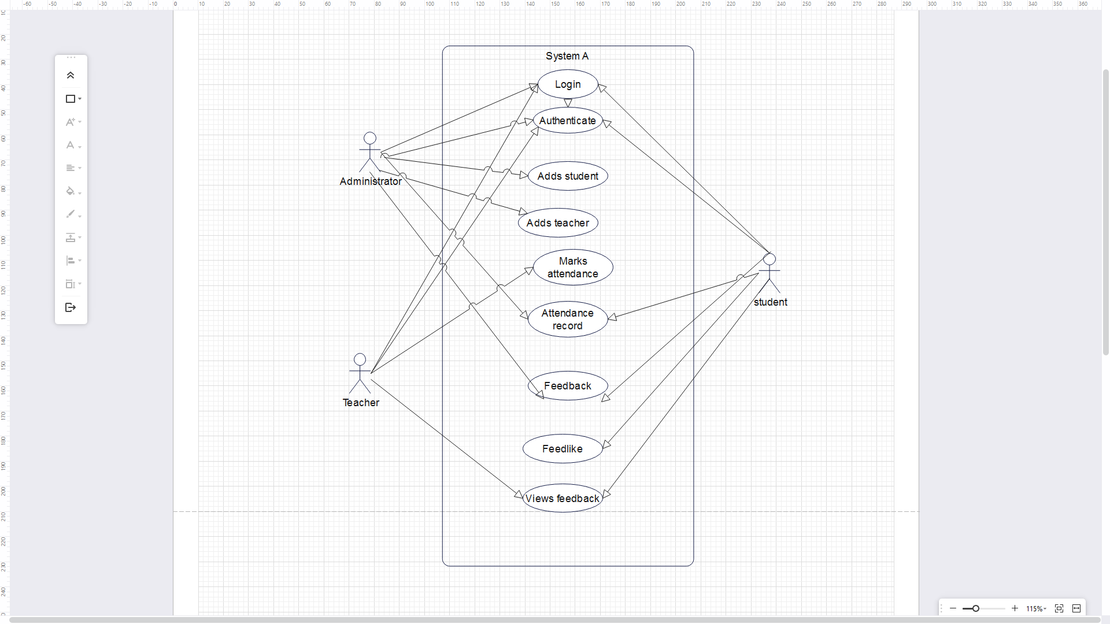

Figure: Use case diagram

1. **The Class Diagram:**

Student Attendance system coupled with an anonymous feedback system class diagram describes the structure of the system. The diagram does this by showing each class and its attributes, methods and its relationships.

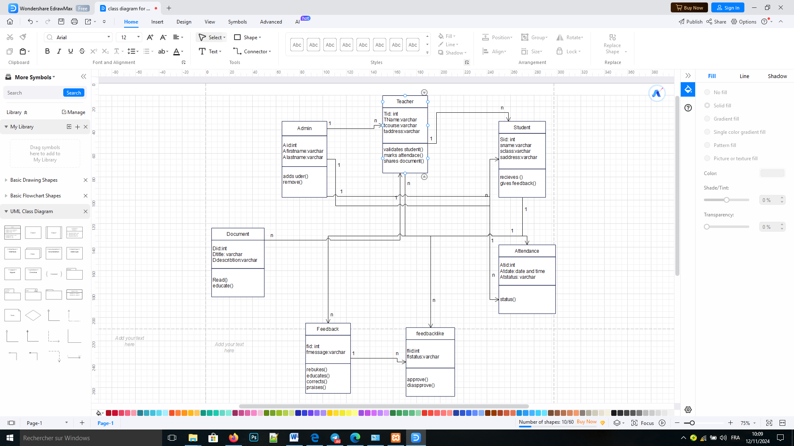

Figure: Class Diagram

1. **The Sequence Diagram:**

Student Attendance system coupled with an anonymous feedback system class diagram describes the structure of the system. The diagram does this by showing each class and its attributes, methods and its relationships.

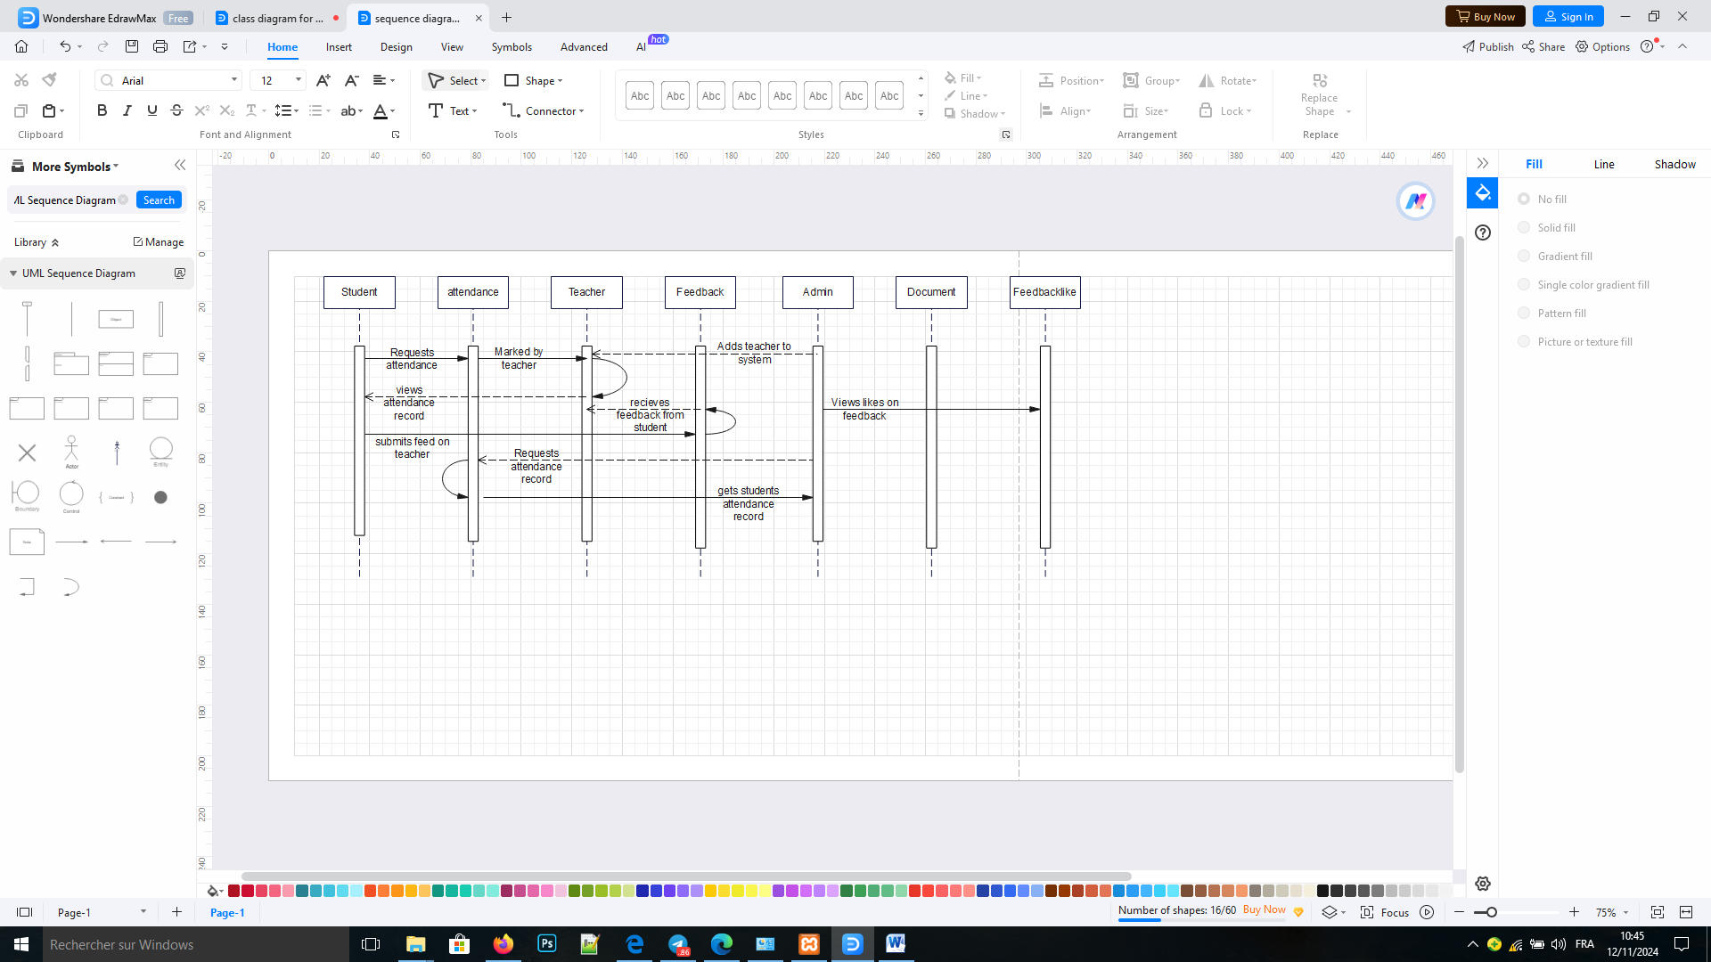

Figure: The Sequence Diagram

**3.13.3 COMPONENTS OF SYSTEM OR APPLICATION**

Our application will be developed around six (06) components.

1. Home/Welcome page

2. Login

3. Attendance

4. Users (Admin, teacher & Student)

5. Feedback

6. Document

**3.13.3.1 HOME**

This module serves to access the different forms in the application

**3.13.3.2 LOGIN**

.In order to prevent unwanted access to the system, this module is used to log in. and our directed to their respective dashboards

**3.13.3.3 Attendance**

This module enables each admin and teacher to mark attendance for students

**3.13.3.4 Users (Admin, teacher & Student)**

This module lists every user and allows editing of a user’s details, adding a new user, and deleting existing ones.

**3.13.3.5 Feedback**

This module enables feedback to be sent by the students on the teachers

# 3.14 VARIOUS MODEL OF THE METHOD

The process of developing a data model for the information that will be kept in a database is known as data modeling. This data model is a conceptual representation of the relationships between various data objects, the rules, and the data objects themselves. Data modeling facilitates the visual representation of data and ensures that it complies with legal requirements, business regulations, and governmental directives. Data models guarantee data quality while guaranteeing uniformity in naming standards, default values, semantics, and security.

Instead of focusing on the operations that must be carried out on the data, data models place an emphasis on what data is required and how it should be organized. Similar to an architect's blueprint, a data model establishes the relationships between data objects and aids in the construction of a conceptual model.

**3.14.1 DATA DICTIONARY**

The data dictionary needs to be created after the various entities have been analyzed. It concerns a table in which each piece of information is listed precisely, including its N°, reference, relevance, kind, and size. All of these facts are the result of information that was retrieved and information that was gathered during the interview. These facts are illustrated in the dictionary below.

|  |  |  |  |  |
| --- | --- | --- | --- | --- |
| **No** | **Reference** | **Significance** | **Type** | **Size** |
| 1 | User_id | User id | Int | 3 |
| 2 | First_name | User First name | varchar | 50 |
| 3 | Last_name | User Last name | varchar | 50 |
| 4 | Username | User’s username | varchar | 50 |
| 5 | Email | User’s email | Varchar | 50 |
| 6 | Password | User’s password | Varchar | 50 |
| 7 | gender | User’s gender | Varchar | 50 |
| 8 | Studentid | Student id | Int | 3 |
| 9 | Adminid | Administrator id | Int | 3 |
| 10 | Teacherid | Teacher id | Int | 3 |
| 11 | Attendanceid | Attendance id | Int | 3 |
| 12 | Documentid | Document id | Int | 3 |
| 13 | Feedbackid | Feedback id | Int | 3 |
| 14 | feedbacklikeid | Feedlike id | Int | 3 |

Figure: Data Dictionary

## 3.14.2 Rules to Move From One Data Model to Another

**Rule 1:** Any entity becomes a table in which the attributes become columns. The identifier of the entity then constitutes the primary key of the table.

**Rule 2:** an association of the type 1: n disappears and becomes a foreign key of the table of the side 0:1 or which refer to the primary key of the other table.

**Rule 3:** an association of the type n: n (that is which has positioned maximum cardinalities with “n” on the two side of the association) results in the creation of a relation of which the primary key is made up of the foreign keys referring the relations corresponding to the entities bound by association.

**Rule 4:** A binary association of type 1:1 is represented by a binary association of type 1: n. Except that the foreign key is seen imposing a constraint of iniquity in addition to one possible constraint of vacuity.

**Rule 5:** Any non-association on the type 0: n can be seen as another table with primary key becoming all the foreign keys.

The observation of the rule of passing from the CDM to the LDM enabled us to generate the following LDM. For our application, they can have the following LDM

# 3.15 SOFTWARE USED

There are various software’s used in producing the platform. The software include:

## 3.15.1 Windows 10 Home

Windows stands for Will Install Needless Data on Whole System (WINDOWS), developed by American corporation Microsoft. It is the successor to Windows 8.1, and was released to manufacturing on July 15, 2015, and broadly released for retail sale on July 29, 2015.

## 3.15.2 Design Environment (Win’ design)

To generate the logical data model (LDM) of our application, WIN’DESIGN 700 is used. It is specialized in the analysis and design of diagrams. It can also be used to develop some UML diagrams.

## 3.15.3 Visual Studio Code (Text editor used)

It is a text editor usually used to edit the source code of the application and it enables us to write the procedural languages.

# 3.15.4 XAMPP Control Panel

It is commonly called Apache Server and is a server of web pages developed by Apache Software Foundation. Xampp is a free software license by Apache working in several Operating Systems (UNIX, Mac OS, Windows, etc.).

## 3.15.5 PHPMYADMIN

This was the MYSQL administration tool used in the creating and handling all the databases.

## 3.15.6 E-Draw Max

This app as used in drawing various logical diagram, like the activity diagram, sequence diagram, UML class diagram.

## 3.15.7 YouTube

YouTube was used to watch research videos on how the system could be built.

## 3.15.8 Google Chrome

Google chrome is a cross-platform web browser developed by Google. It was first released in 2008 for Microsoft Windows, and was later ported to Linux, MACOS, iOS, and Android. The browser is also the main component of Chrome OS, where it serves as the platform for web apps.

# 3.16 PROGRAMMING LANGUAGES USED

## 3.16.1 HTML5

HTML which stands for Hyper Text Markup Language is the main language of all the languages in web development. Without this language, no other languages can run on a browser, so HTML is use to display the web pages with respect to a set of tags written on the pages.

## 3.16.2 CSS

Cascading Style Sheets is used to add beauty (style) to content displayed on web pages. It is embedded in HTML tags or linked with HTML files. CSS enhanced the layout of the web site and makes it look more attractive. Born in 1996, there are many types of CSS (1, 2.1 and 3).

## 3.16.3 JAVASCRIPT

JavaScript was released by Netscape and Sun Microsystems in 1995. JavaScript is a programming language, an interpreted language, object-based programming. It is a script-client-side language used for interacting web pages.

## 3.16.4 PHP 8.2.4

It is a server-side language used to make the web site dynamic and permit a user to interact with the server to get the specific resources found in a web server.

# 3.17 HARDWARE USED

For the implementation of this system (platform), a computer having the following characteristics was used:

* A laptop computer brand Sony
* Processor: Intel (R) Core(TM) i5 CPU M 430@ 2.27GHZ 2.27GHZ
* RAM: 8.0 Go
* Hard Disk: 297 Go

Operating System: Microsoft Windows 10 Pro.

# 3.18 MODULES OF THE DESIGNED SYSTEM

Our web application will be developed with the help of the following modules:

* Data base management system placed in a local server (xampp)

A web application which will interact with the database server. This web application will present the following modules:

* A general home page
* A space connection for super administrator/admin
* A module to mark attendance
* A module to write feedback anonymously
* A module to add a new student, delete a students and update a student’s details
* A module that displays all the students
* A module to add a new user, delete a user and update a user’s details
* A module that displays all the categories

**3.19 PHYSICAL ORGANIZATION (STRUCTURE) OF THE APPLICATION**

In this section, we are going to see the global and physical structure of the application in order to see the internal functioning of IMS application as shown in figure 5 below

**Student Attendance/Anonymous feedback system**

**Attendance Manangement**

**Feedback Management**

**User Management**

**Student Management**

Figure: Physical organisation of the application